**4.2 User Documentation**

Table of Contents

4.2.1 Introduction to the System 2

4.2.2 How to Install the System? 2

4.2.3 Logging in to the system 6

4.2.4 Working with the Menus 6

4.2.5 Working with the Input Forms and Procedures 8

To change the password: 8

To add new employee: 9

To edit employee details: 11

To delete an employee: 12

To update the salary parameters: 14

To mark daily attendance: 15

4.2.6 Working with the output reports 18

To view the employee reports: 18

To view the monthly attendance report: 19

To view the monthly salary sheet: 20

To view the perspective payslips of employee: 21

4.2.7 Backing up and restoring of data 23

4.2.8 Troubleshooting/Frequently Asked Questions (FAQs) 24

# 4.2.1 Introduction to the System

CapMark Payroll System is the system that marks the attendance of the employees. It keeps the record of the employees, and marks the daily attendance and then calculates the payslips and monthly salary sheet for the employees on the basis of their working days.

# 4.2.2 How to Install the System?

1. Click the setup icon to start.

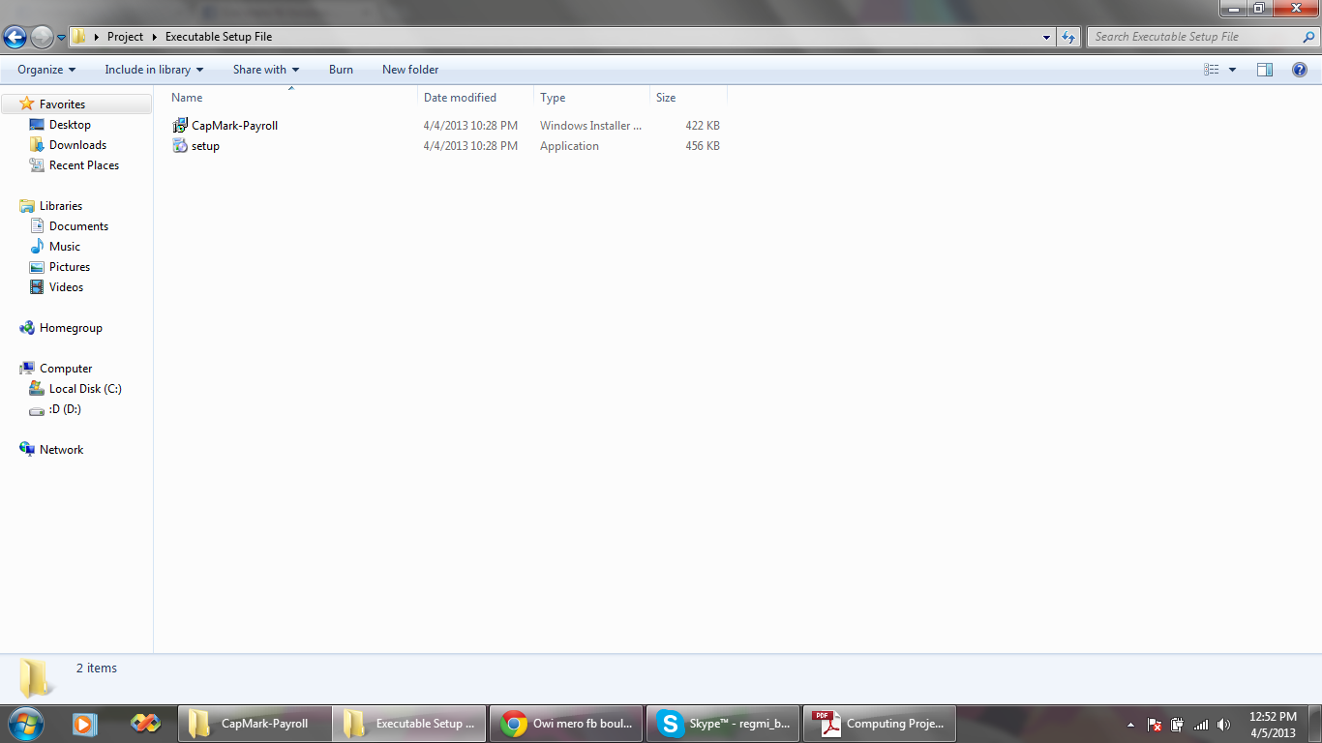

Double-Click this icon to start the setup

1. Click next to proceed

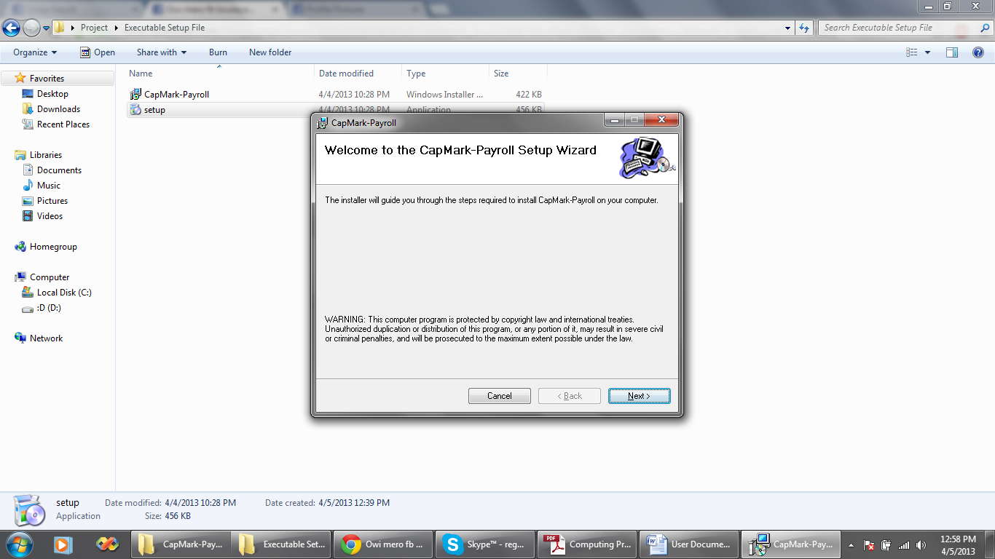

1. Select the folder where to install the file and click Next again.

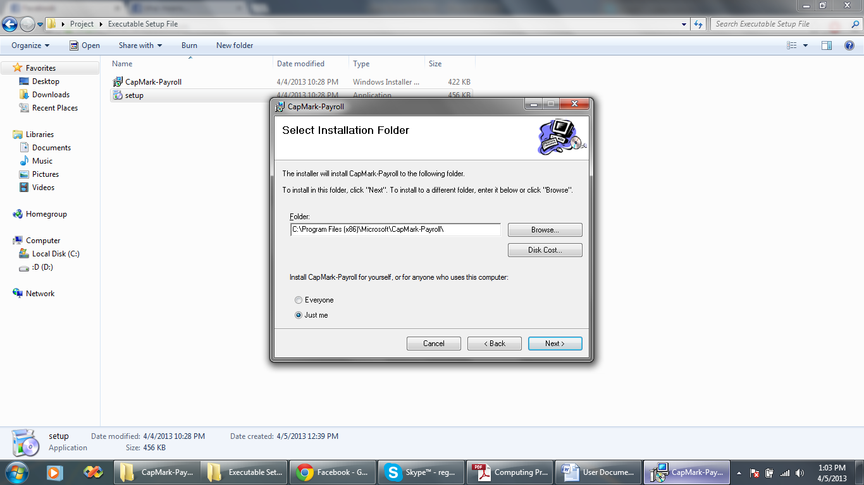

1. Click “Next” again to begin the installation.

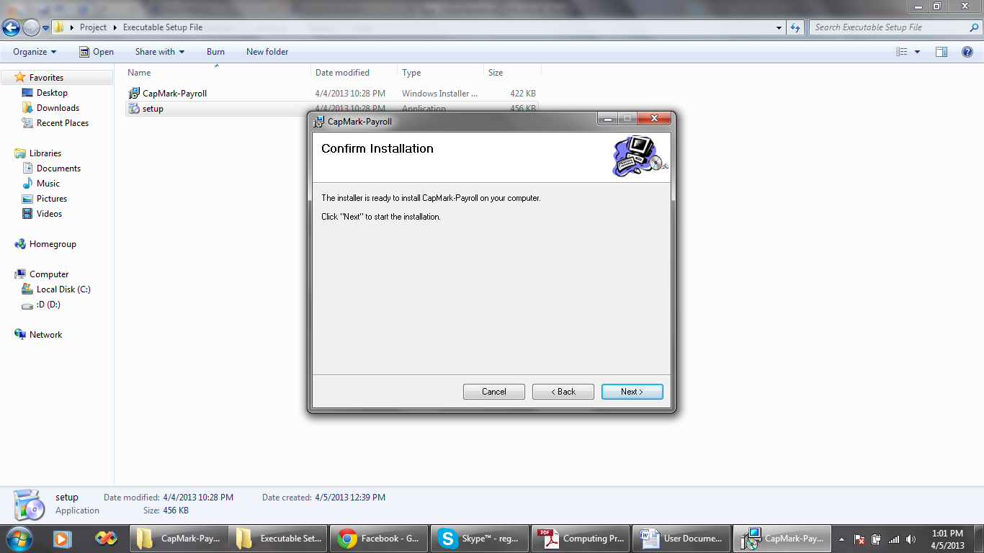

1. An installation dialog box appears. Wait till the installation completes.

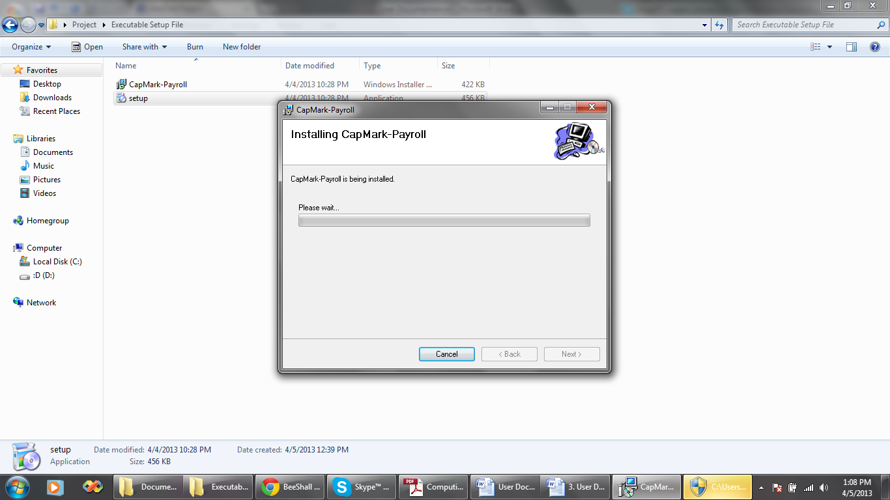

1. After the installation completes, click close to finish the setup.

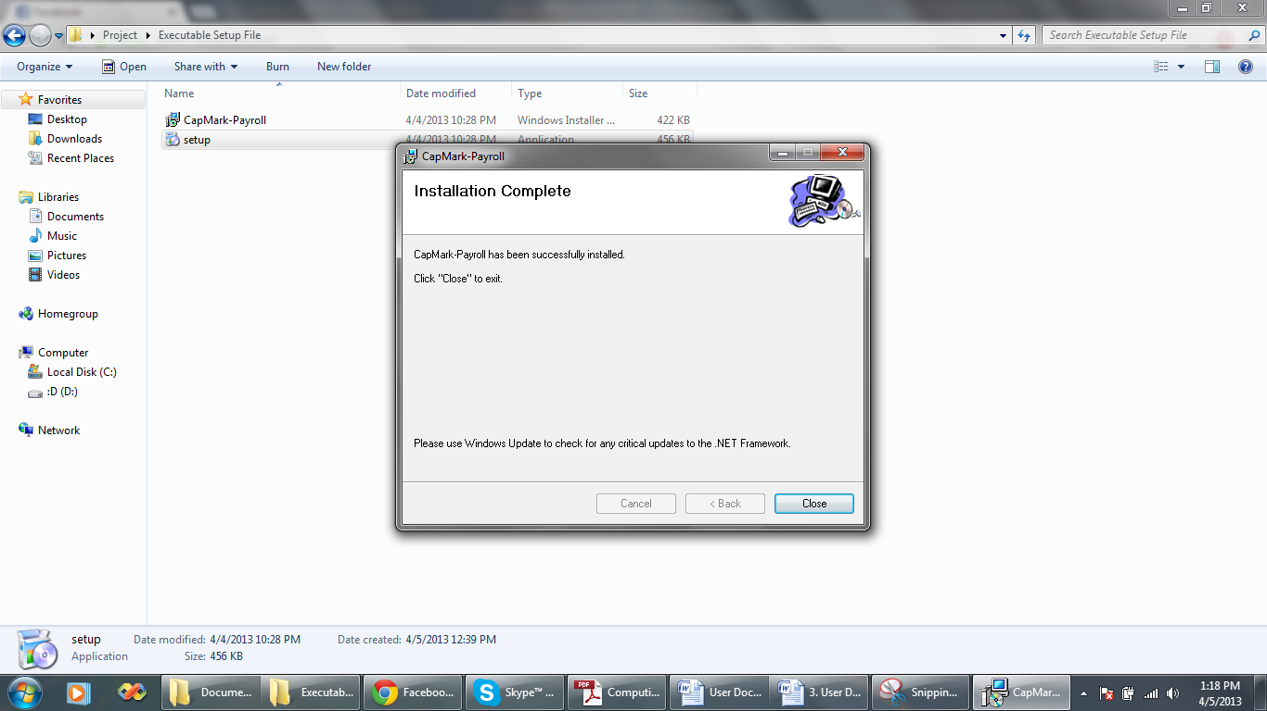

1. Click the Start Menu and click “Payroll” to open the application.

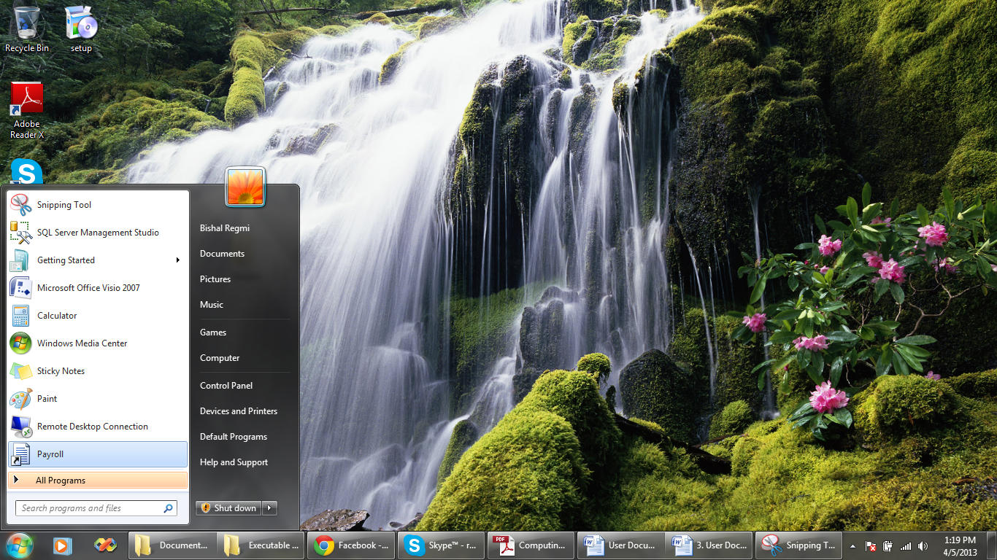

# 4.2.3 Logging in to the system

Open the application. Login form appears. Enter the username and password. Click “Login” to log in to the system and “Cancel” to exit. Try again if the errors are shown for wrong password or empty fields.

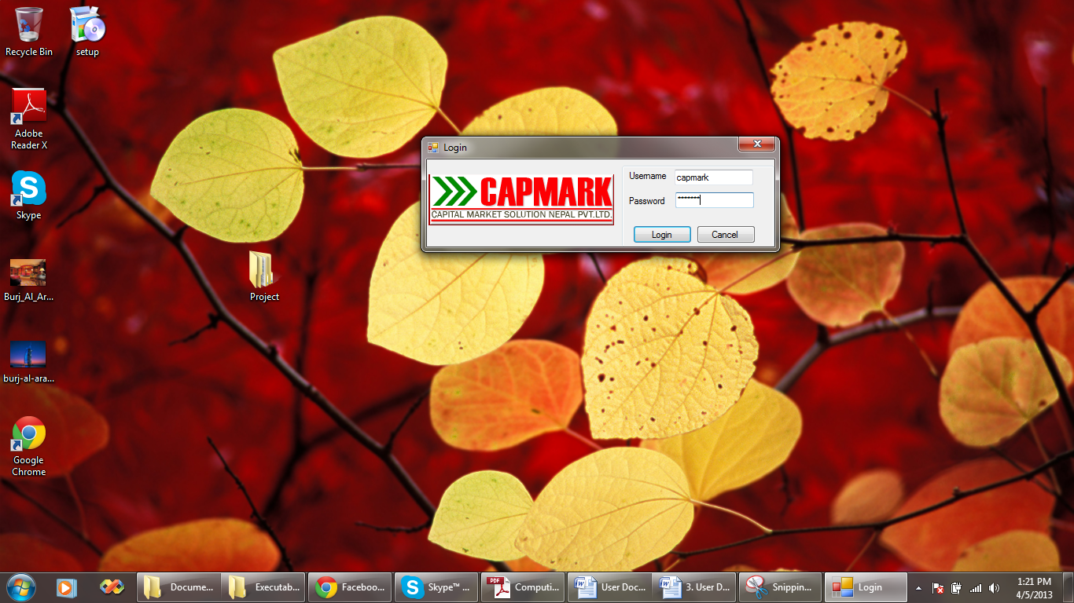

# 4.2.4 Working with the Menus

The main window appears after successfully logging in to the system. There are various menus for the navigations to the internal forms.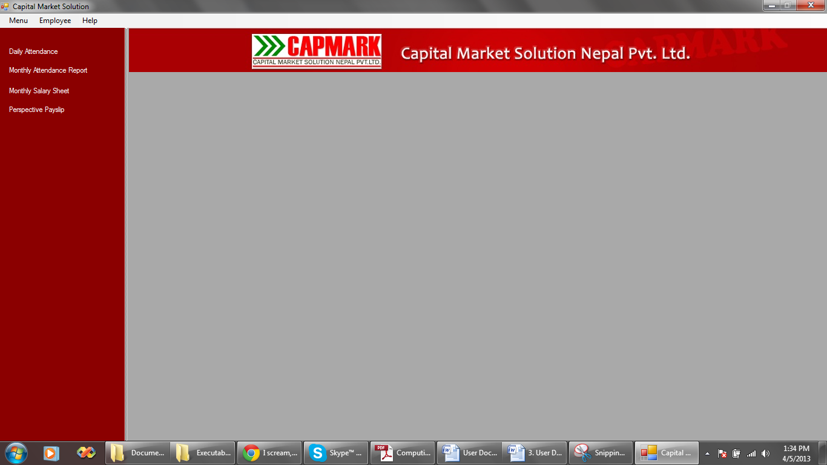

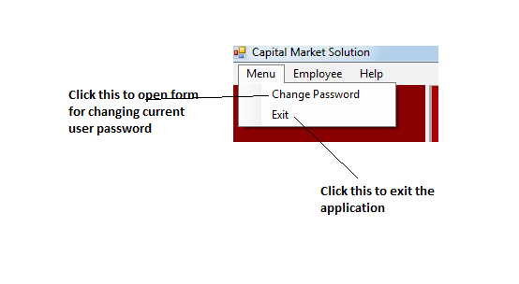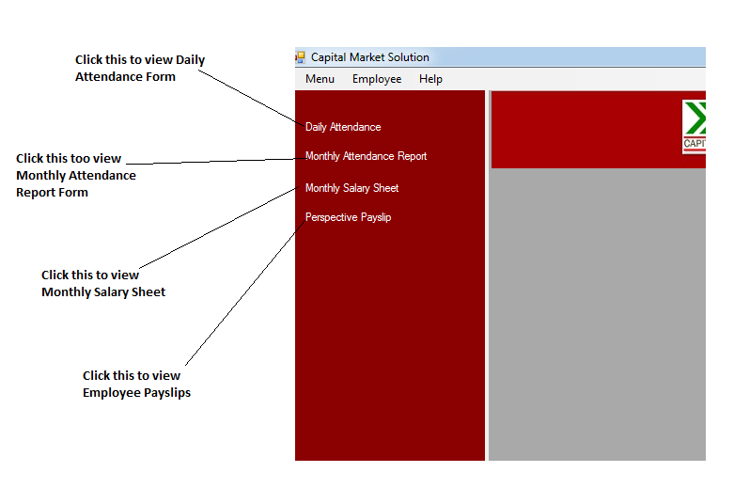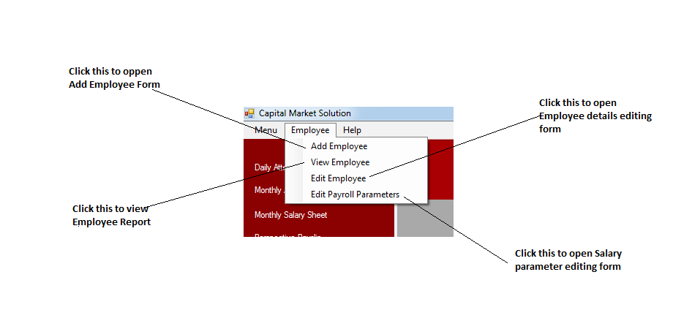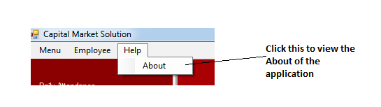

# 4.2.5 Working with the Input Forms and Procedures

## To change the password:

Click “Change Password” option from menu. Enter the old password, new password and confirm password. Make sure the fields are not left empty, the old system password is correct and the new password and the confirm password match. Else, the system shows the corresponding errors. Click “Change” to continue operation.

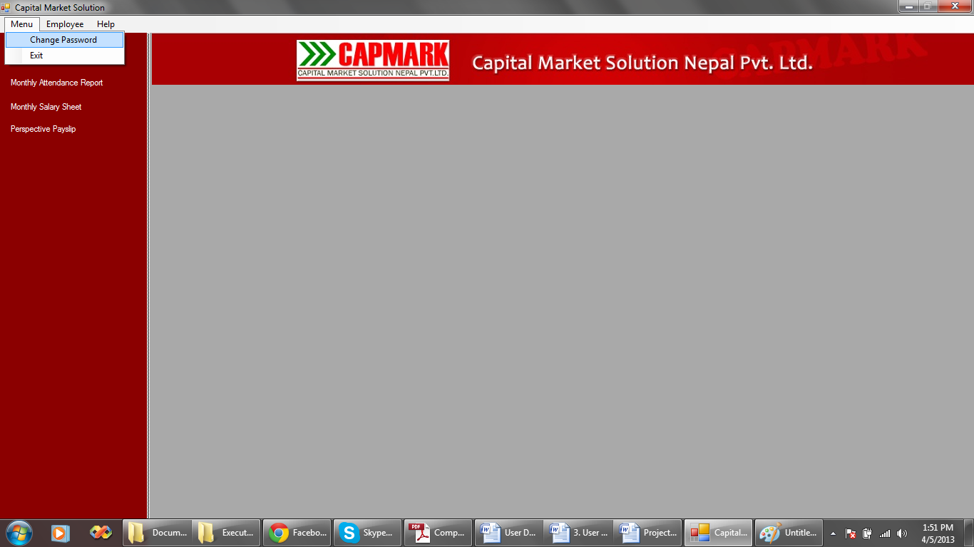

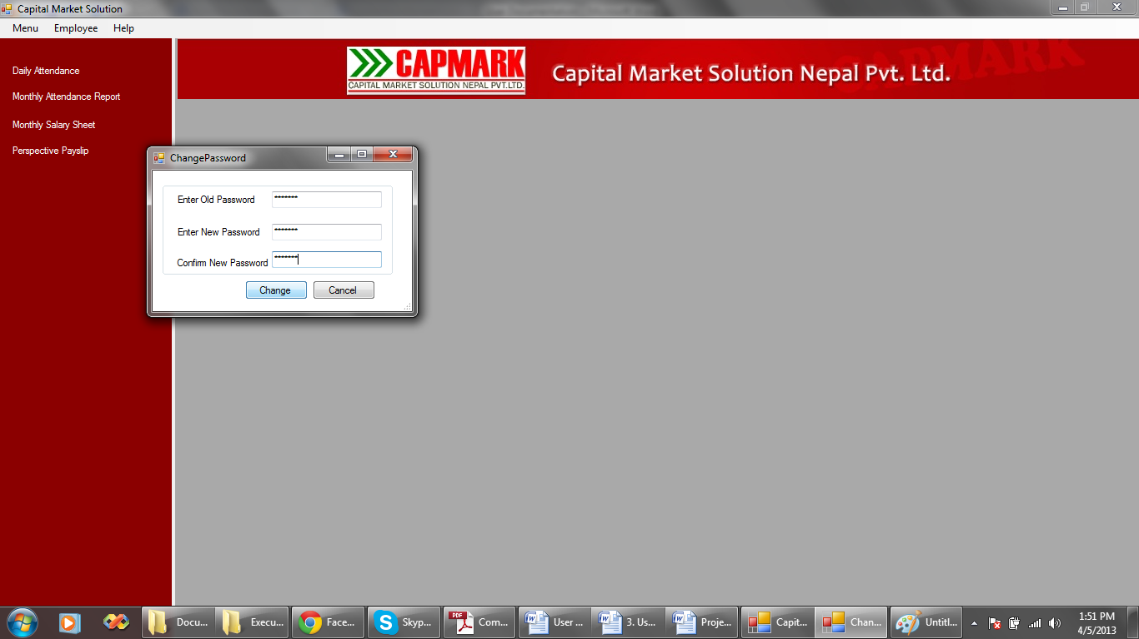

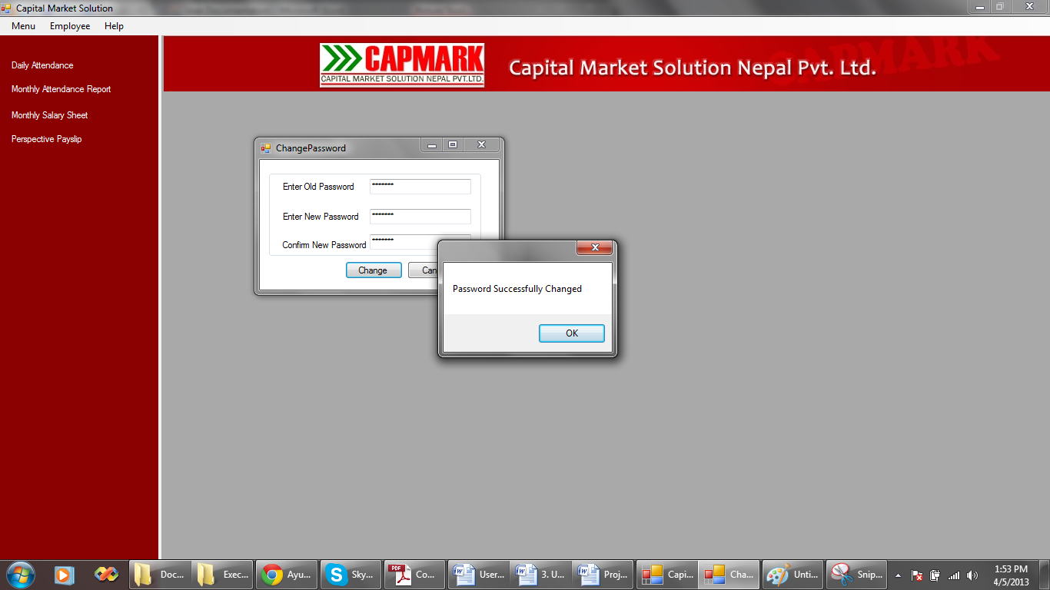

## To add new employee:

Choose “Add Employee” from the employee menu. The field boxes cannot be left empty. Click “Add” button to add the employee.

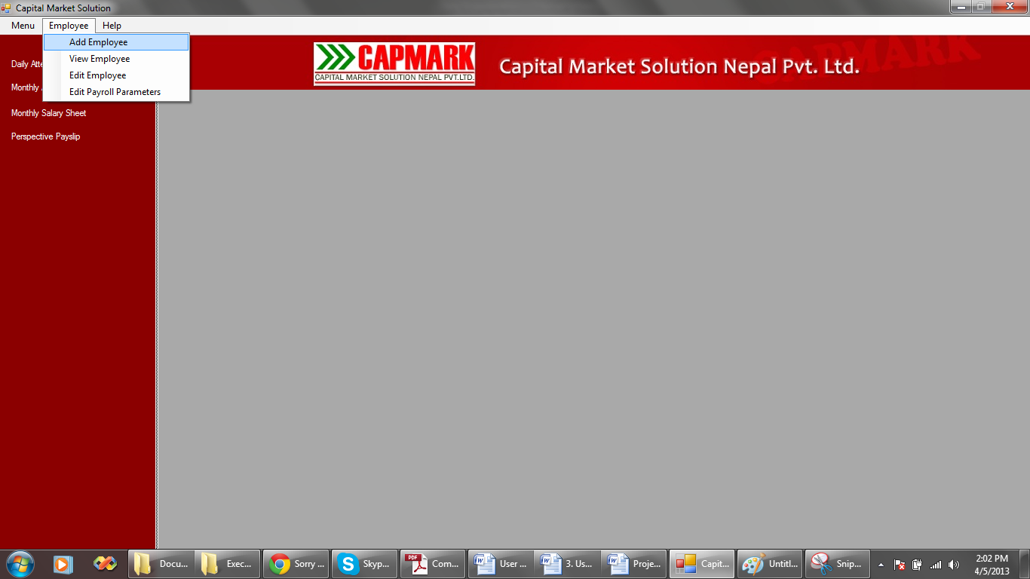



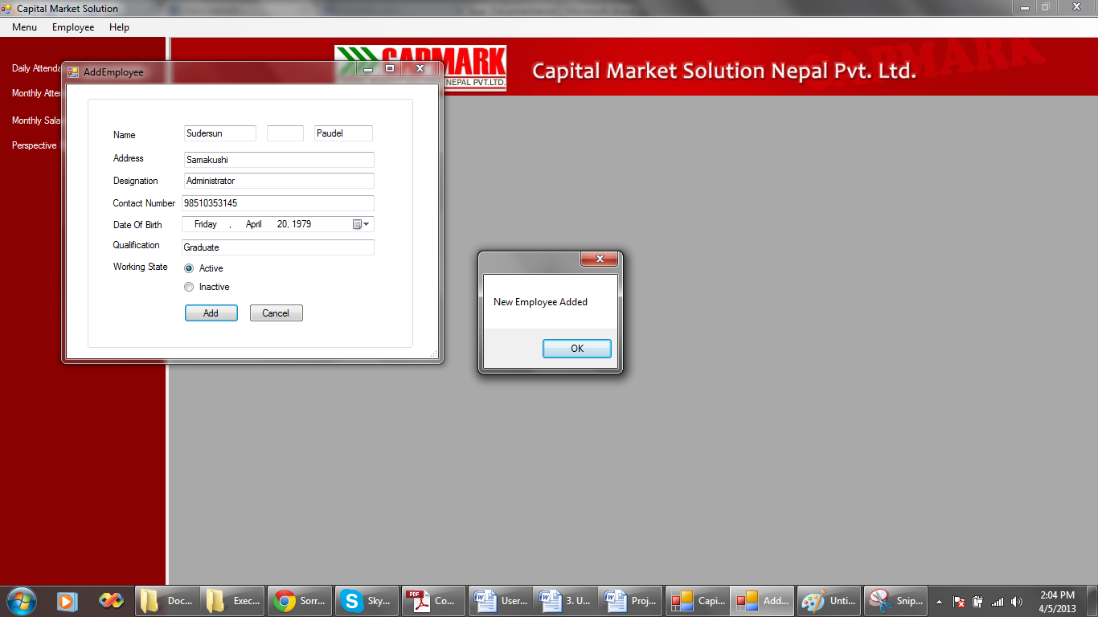

## To edit employee details:

Select “Edit Employee” from the employee menu. Select an employee from the combo box. Change the desired details about the selected employee. Click “Update” button to update the employee details. The gray shaded fields are read-only and cannot be edited.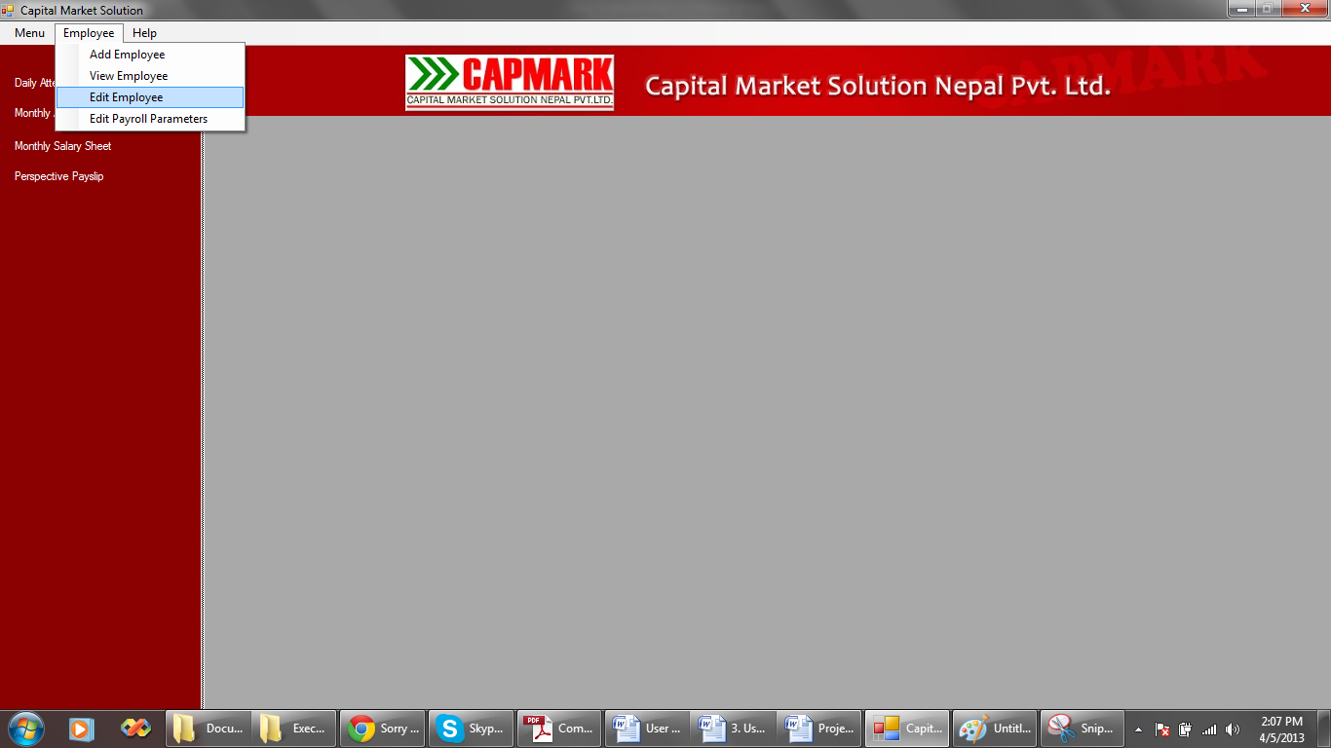

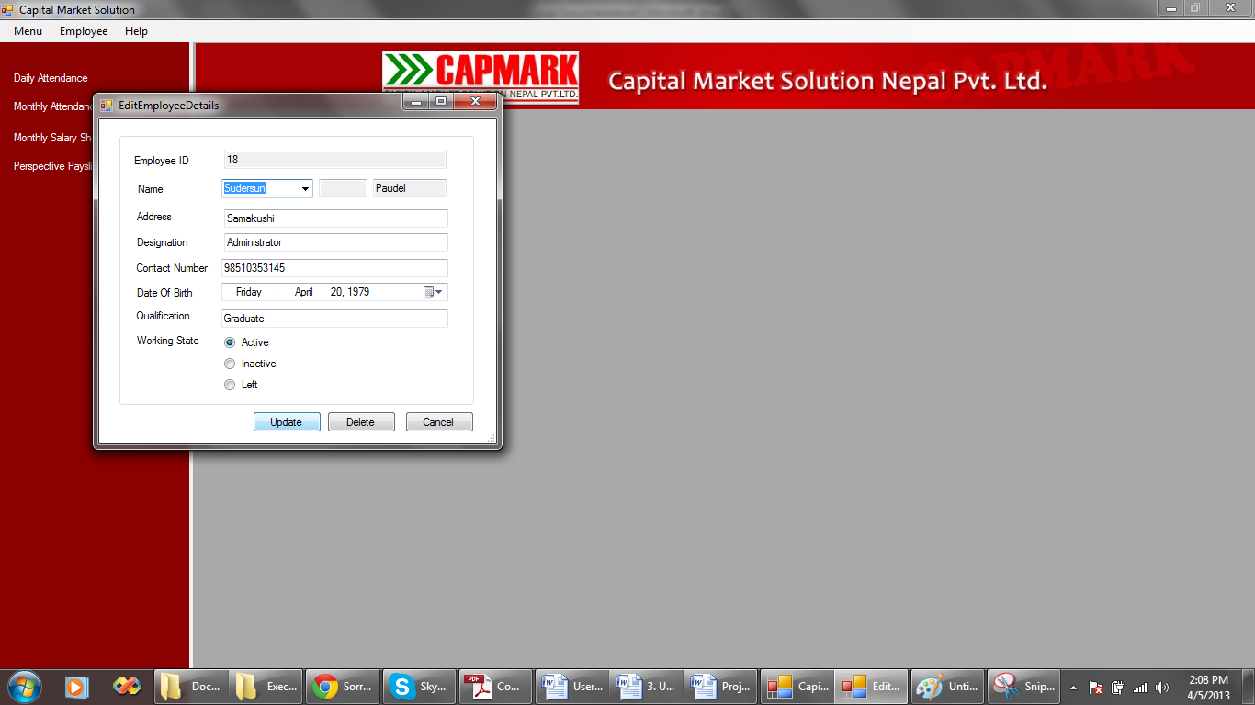

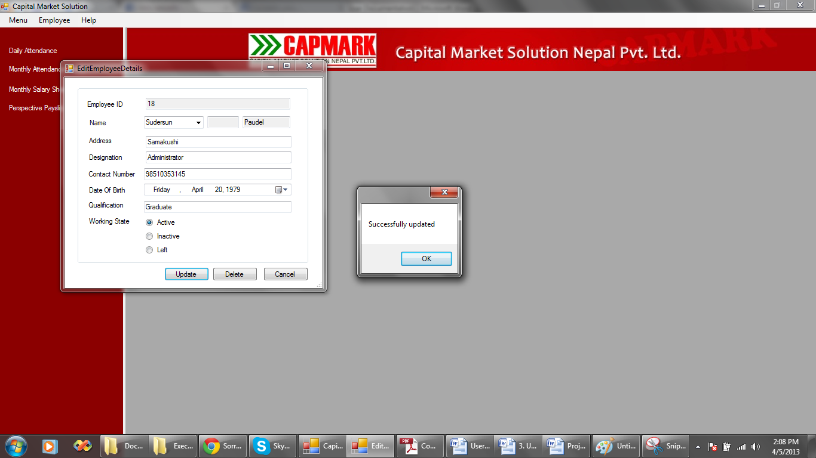

## To delete an employee:

Select “Edit Employee” from the employee menu. Select an employee from the combo box. Click “Delete” button to update the employee details. The gray shaded fields are read-only and cannot be edited.





## To update the salary parameters:

Select “Edit Payroll Parameters” from the employee menu. Select an employee from the combo box. Change the desired details about the selected employee. Click “Update” button to update the salary parameters.

The values for the Basic Salary can only be numbers. The values for Allowance and Insurance can only be numbers and cannot exceed 100. The gray shaded fields are read-only and cannot be edited.

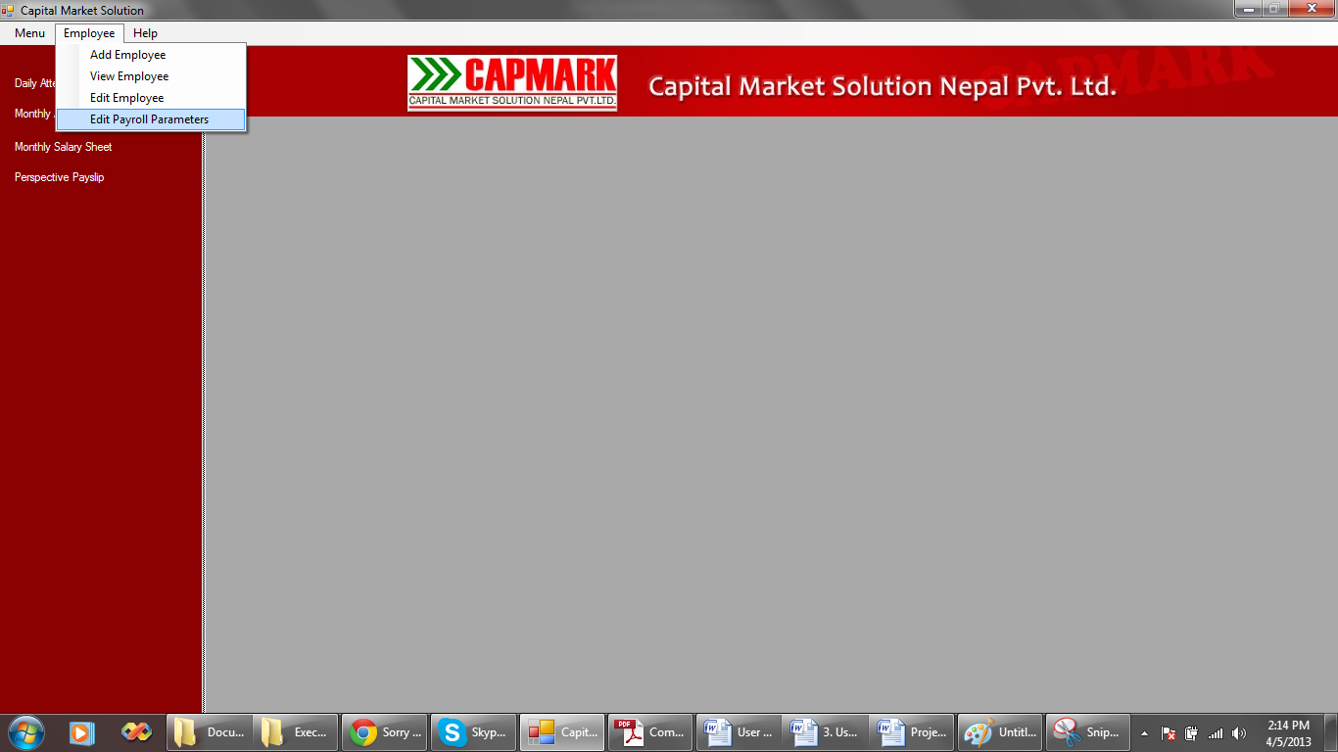

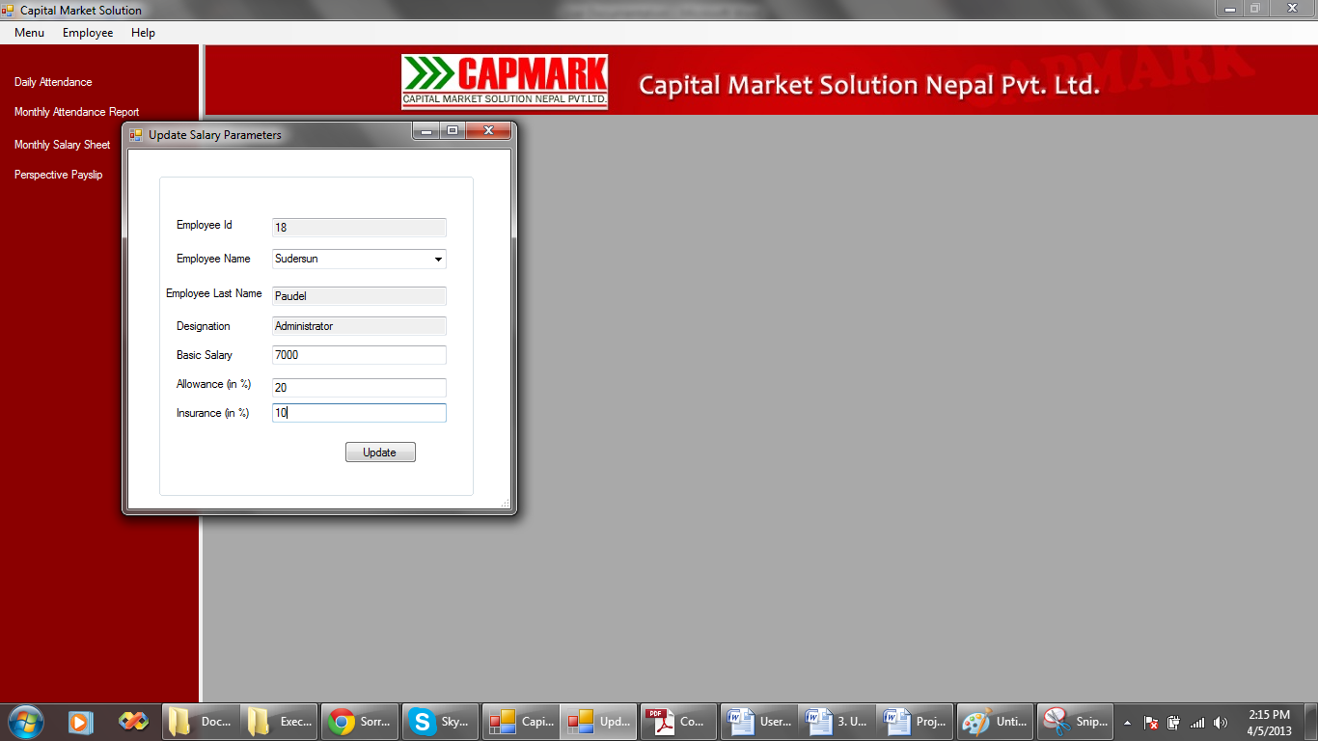

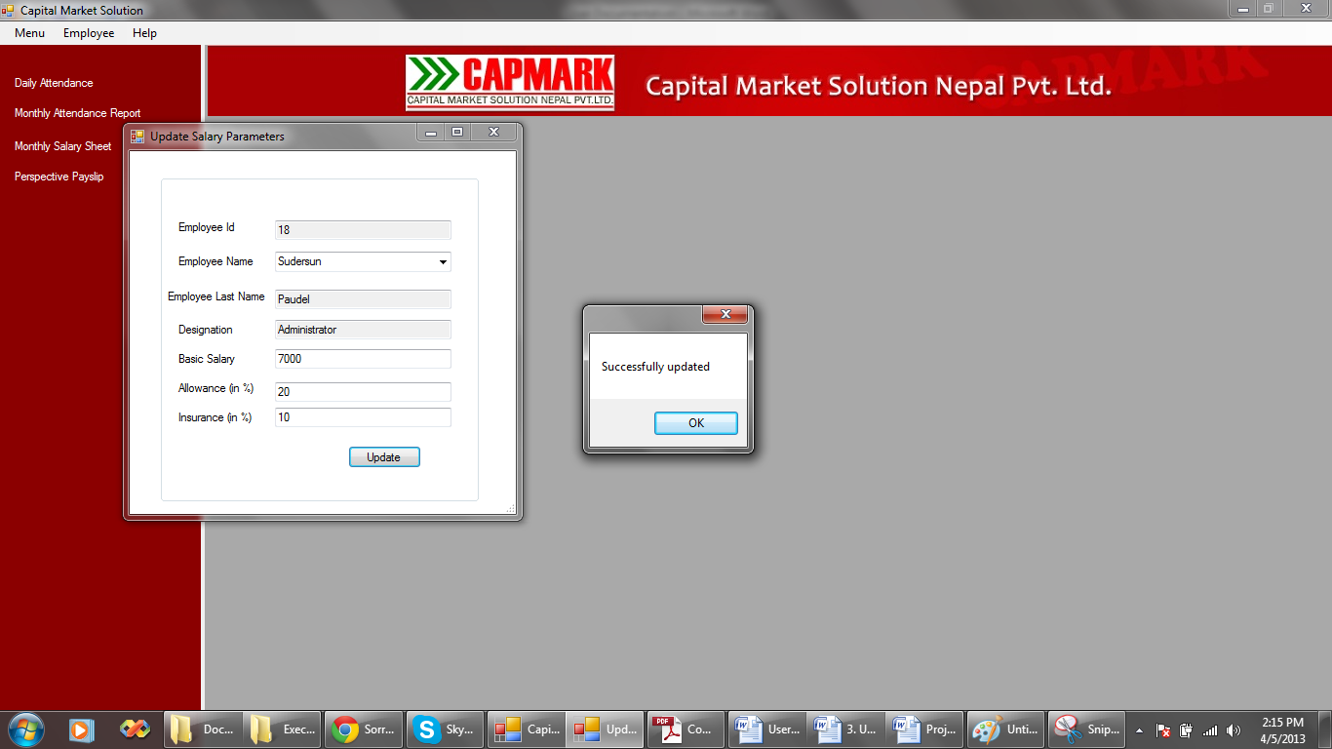

## To mark daily attendance:

Click the “Daily Attendance” label from the side panel. The user control appears on the blank panel. Select the date for when the attendance is to be recorded. Select the employee and the attendance. Click “Done” to mark the attendance.

The attendance cannot be marked for the same employee for the same day more than once. The attendance cannot be marked for the date greater than today’s date.

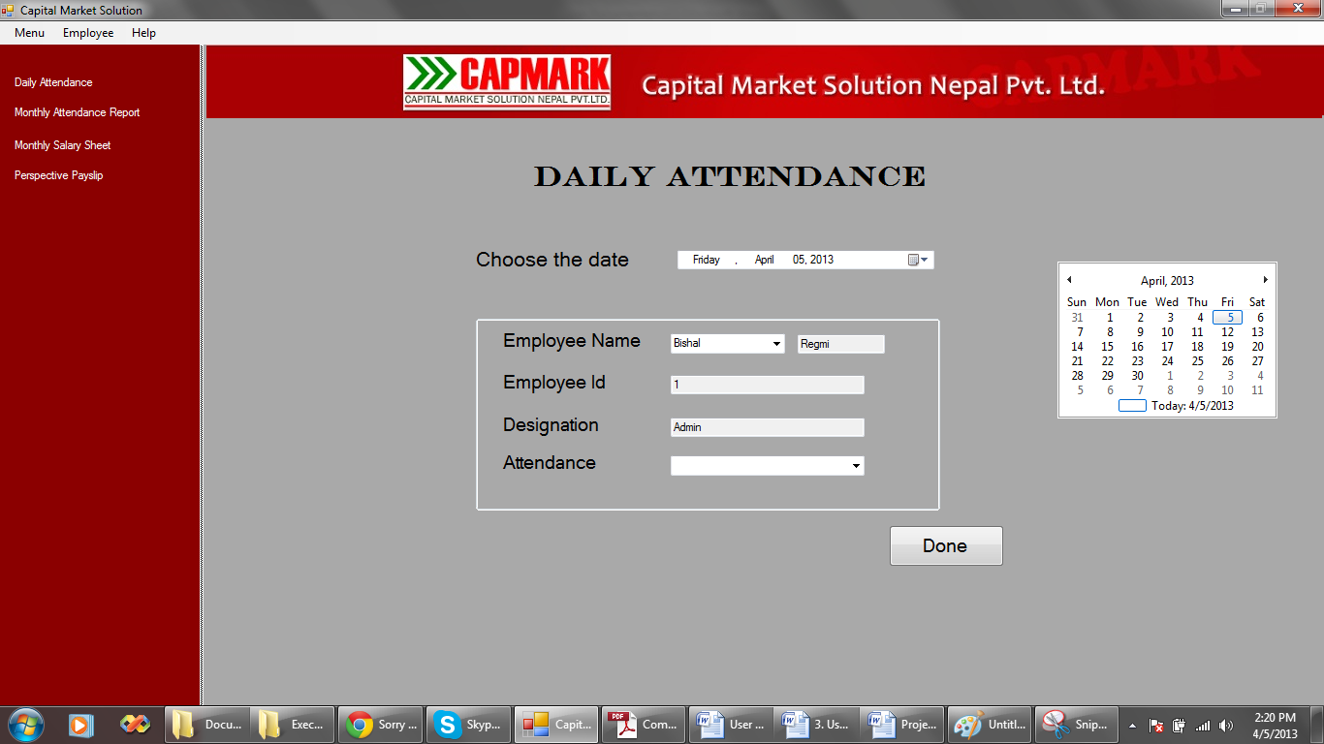

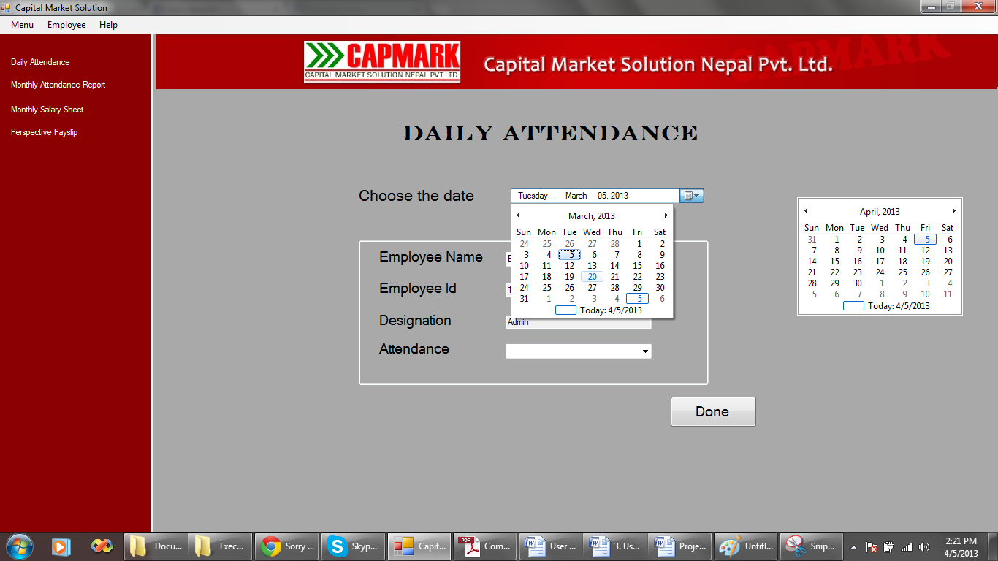

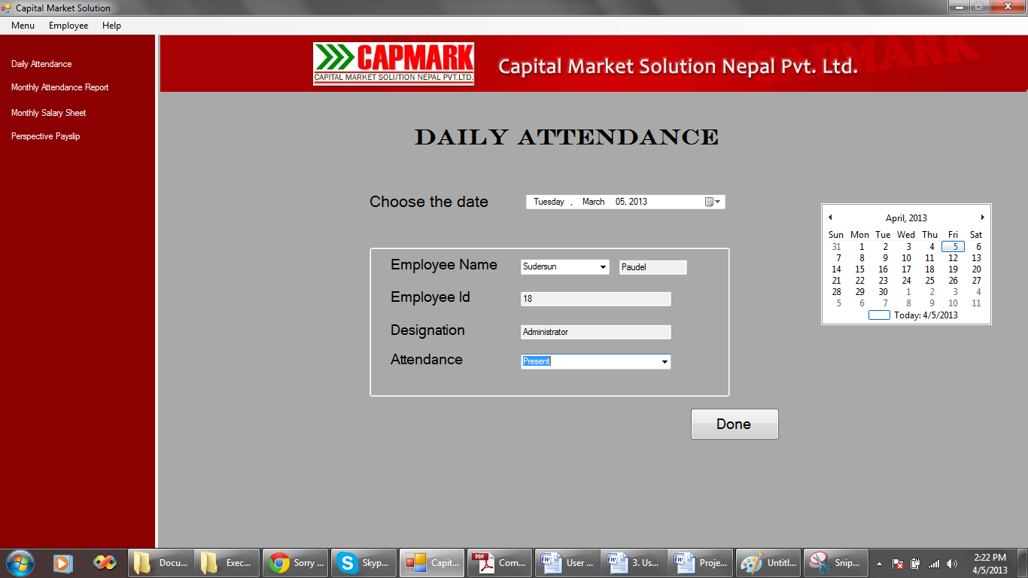

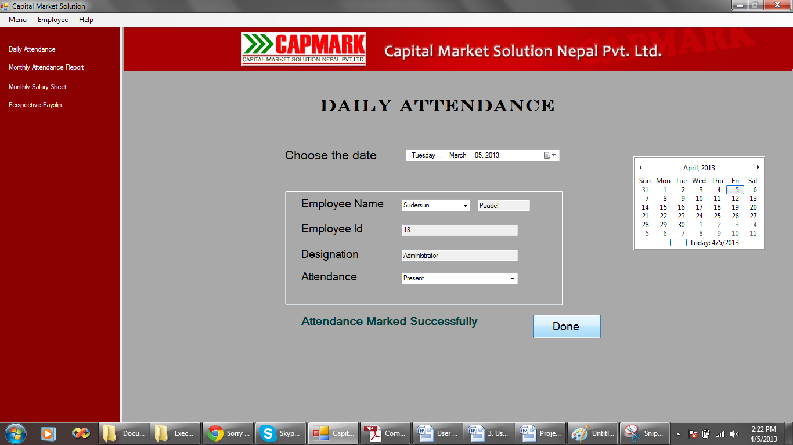

# 4.2.6 Working with the output reports

## To view the employee reports:

Choose “View Employee” from the employee menu. A report is displayed.

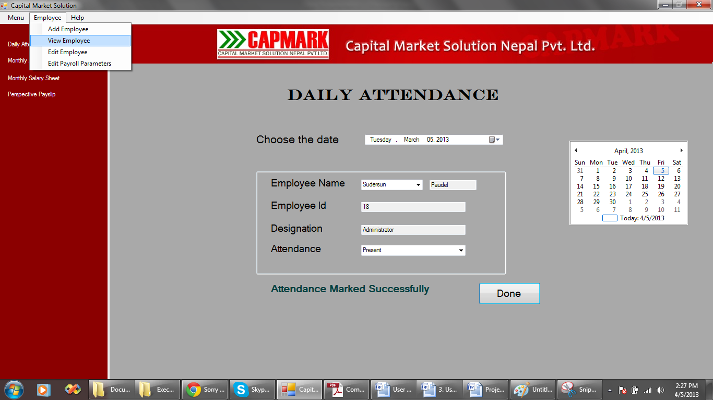

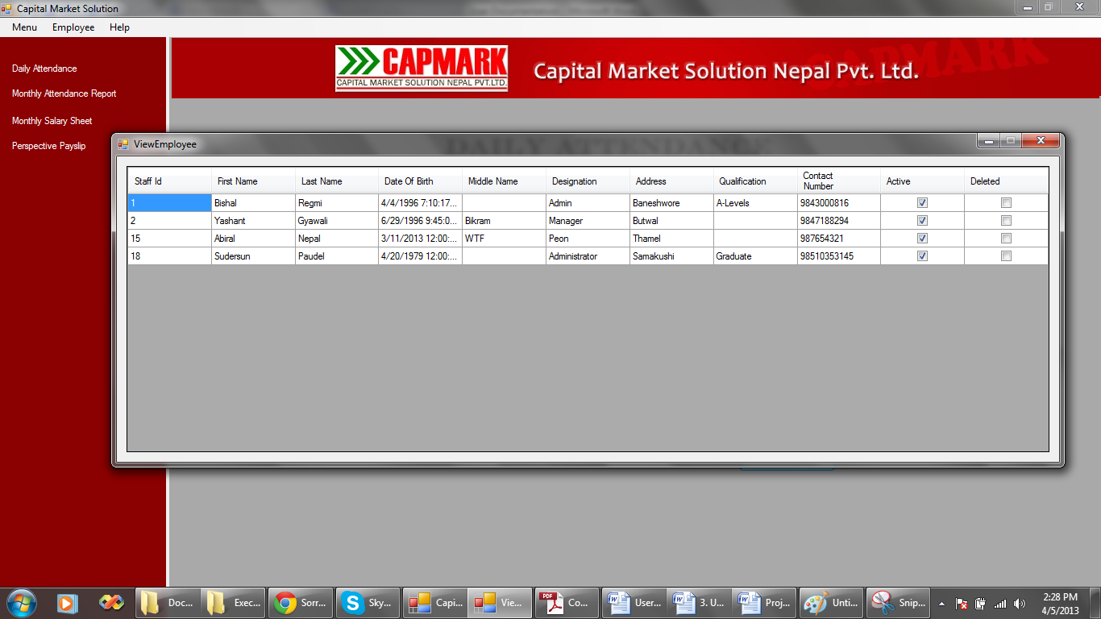

## To view the monthly attendance report:

Click on “Monthly Attendance Report” label from the left panel. The user control is displayed in the right panel. Select the month and year for which the report is to be displayed. Click “Show” to view the attendance report.

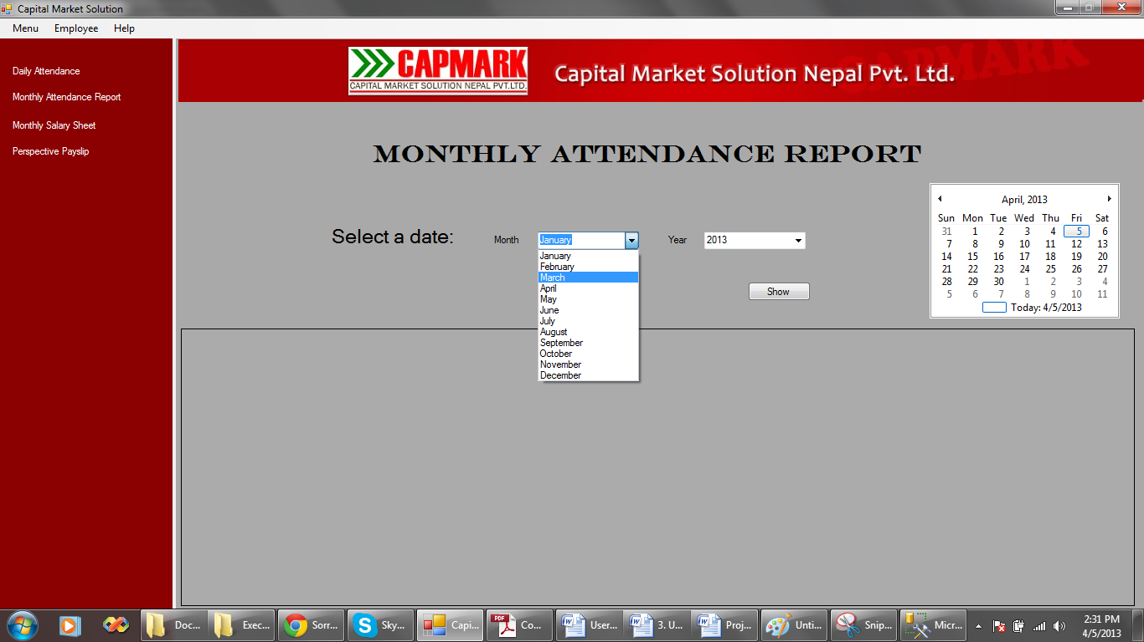 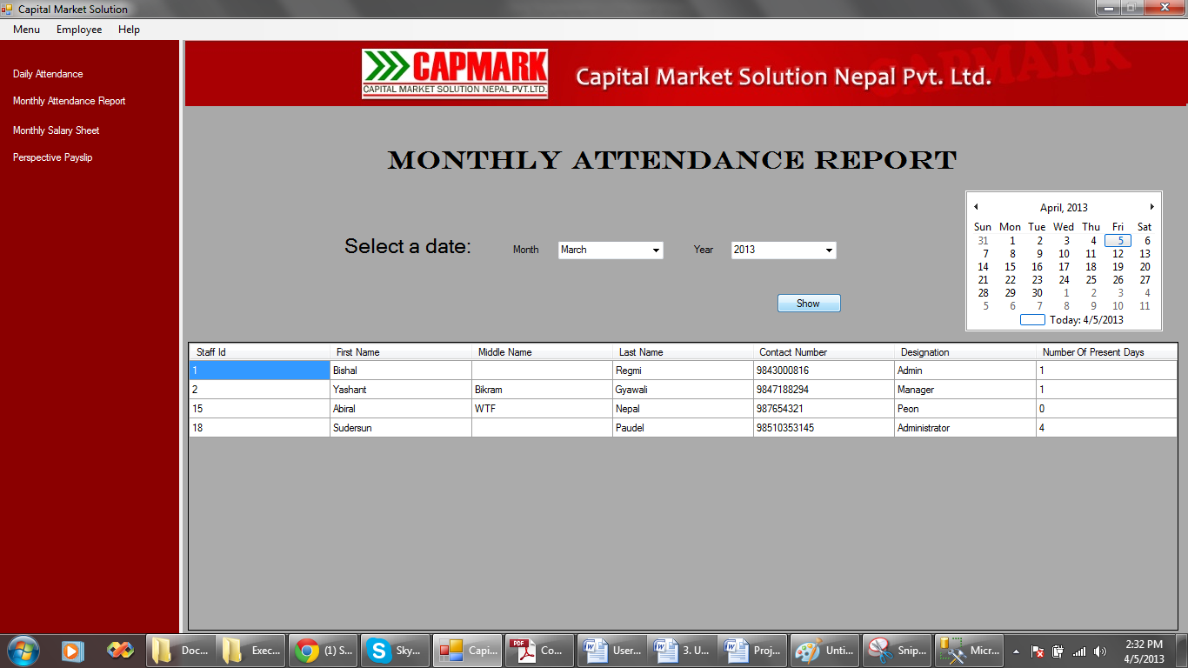

## To view the monthly salary sheet:

Click on “Monthly Salary Sheet” label from the left panel. The user control is displayed in the right panel. Select the month and year for which the report is to be displayed. Click “Show” to view the salary sheet.

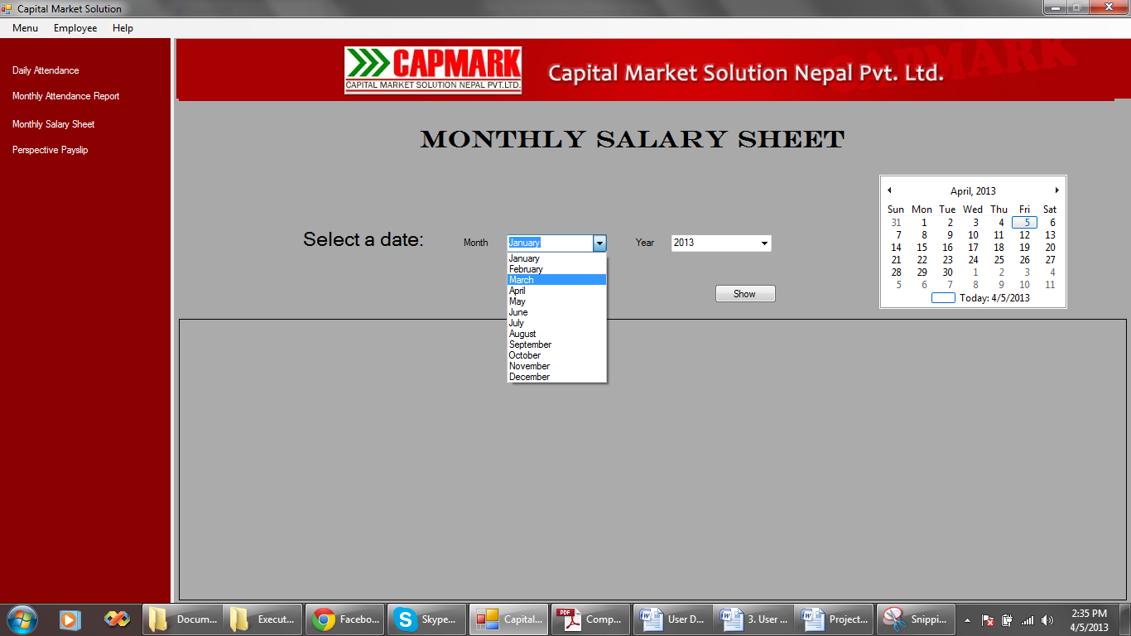 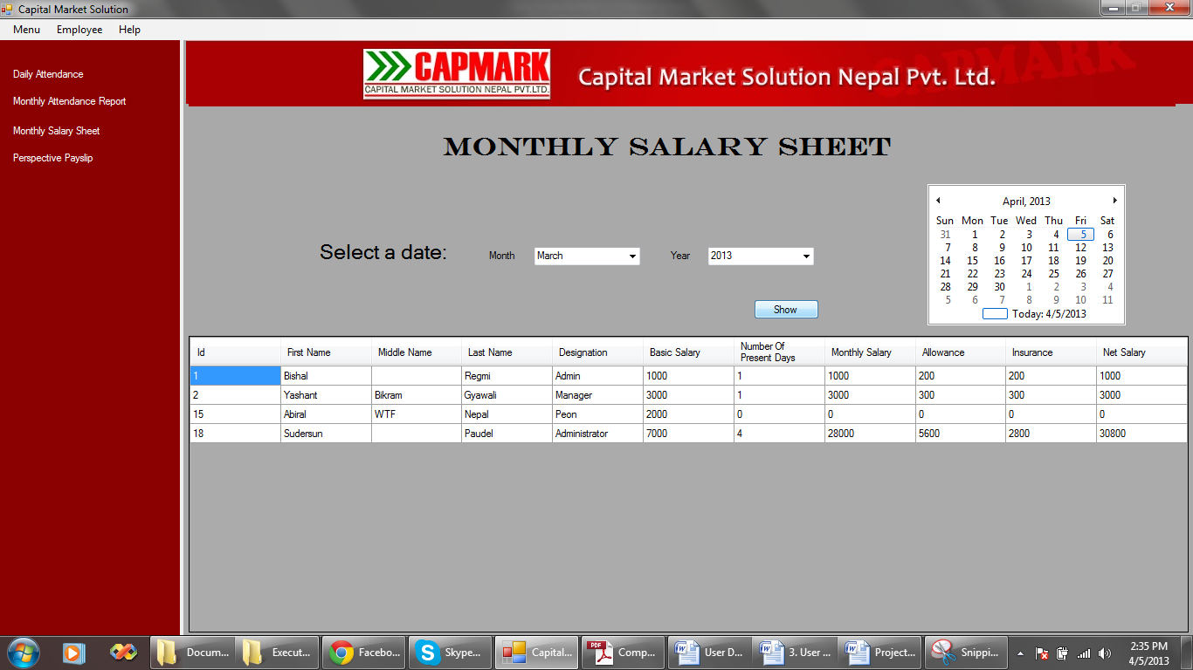

## To view the perspective payslips of employee:

Click on “Perspective Payslip” label from the left panel. The user control is displayed in the right panel. Select the month and year for which the payslip is to be displayed. Select the employee whose payslip is to be displayed. Click “Show” to view the employee payslip.

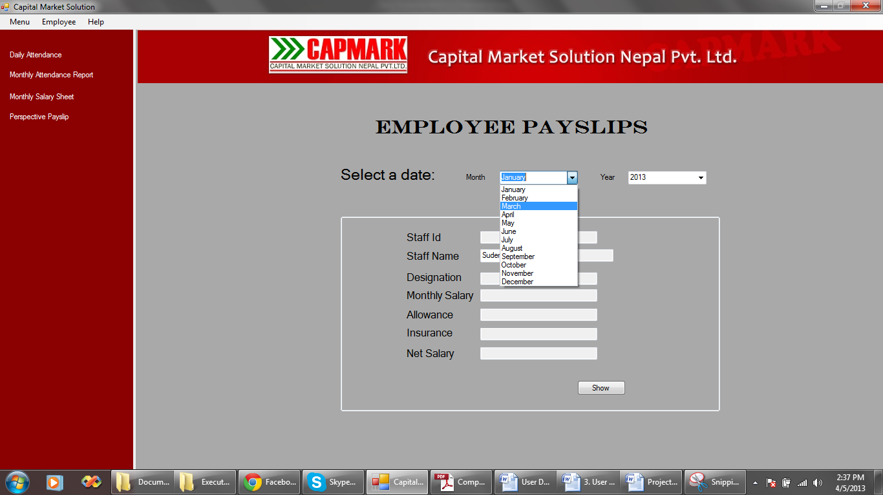

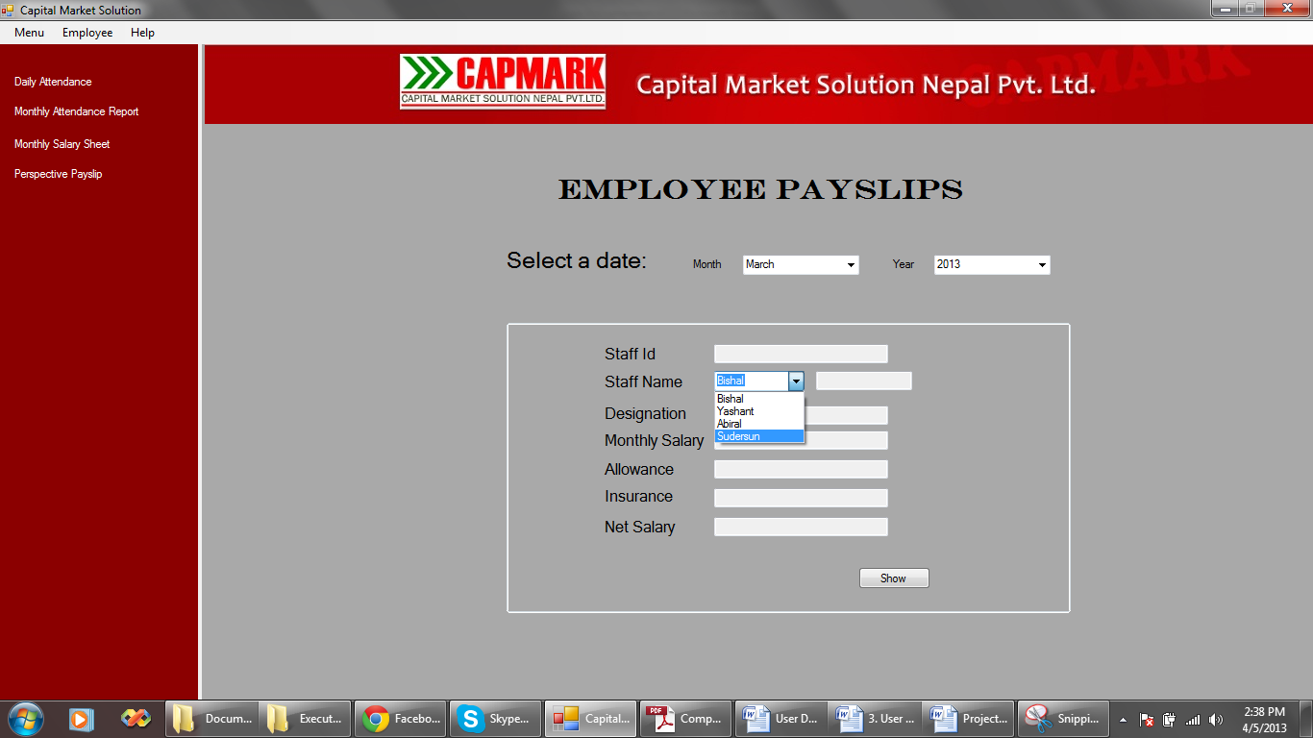

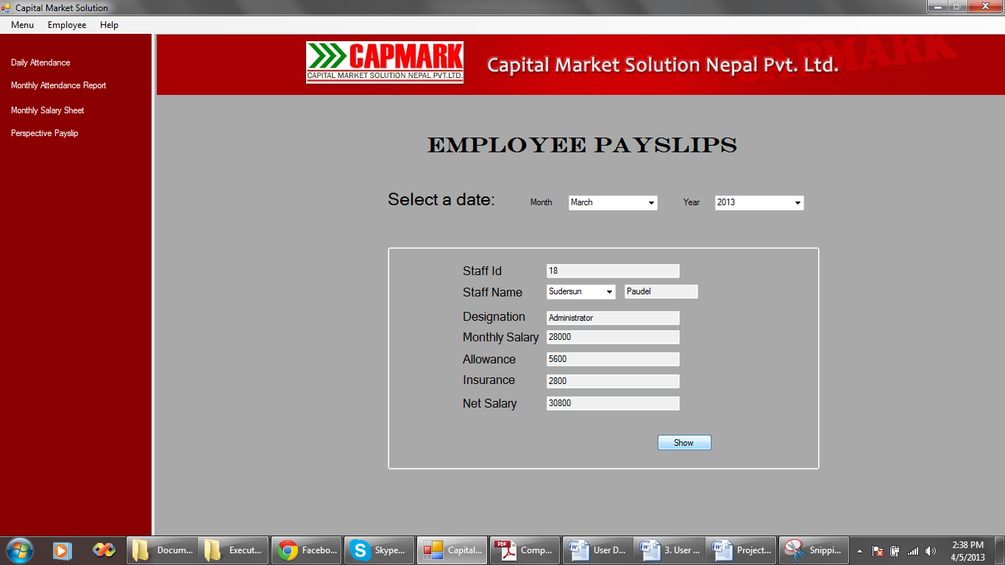

# 4.2.7 Backing up and restoring of data

The backup for the system is not made on a regular basis. The admin makes the backup of the database at the end of the month when the payroll calculation is made.

## Backup Steps:

1. Open Microsoft SQL Management Studio

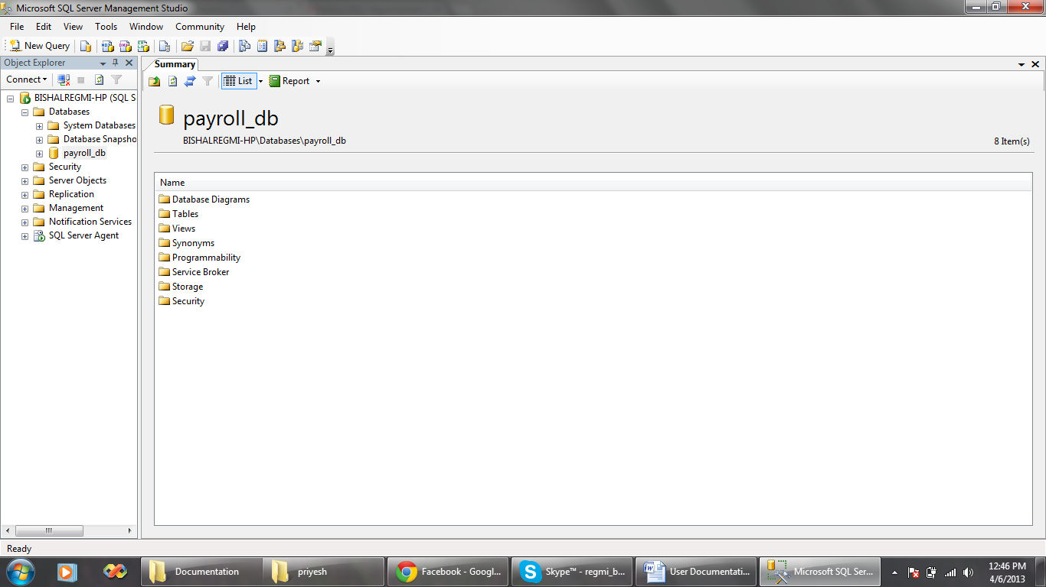

1. Right click on the database. Choose Back Up from Tasks sub menu.

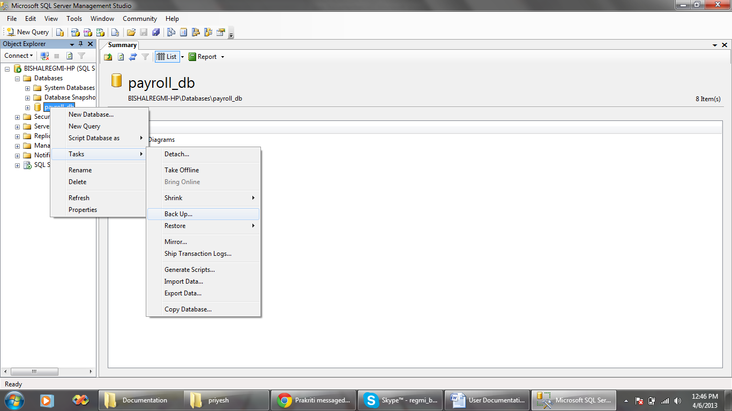

1. Select location to save the backup file. Choose a name for the file. Click OK.

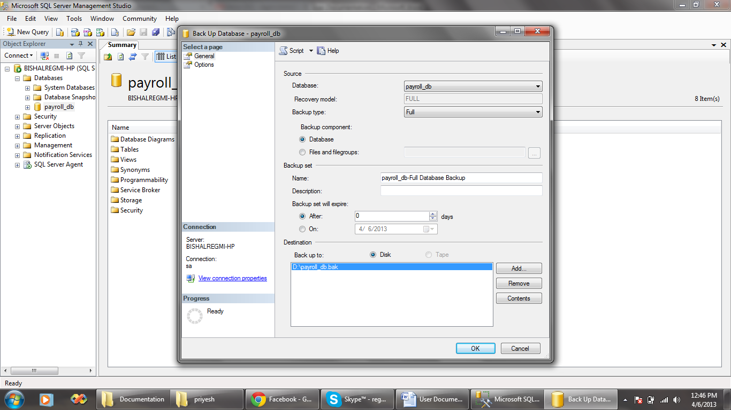

## Restoring the database backup:

1. Right click on the Databases Sub menu and Choose Restore Database.

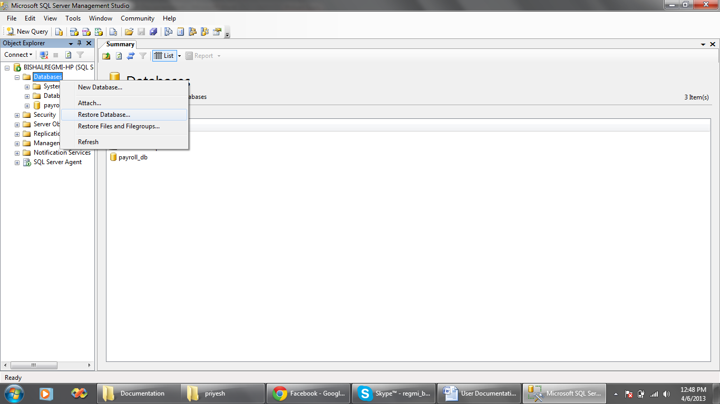

1. Provide a name for the database and specify the backup file. Choose From device option to specify location for the backup file.

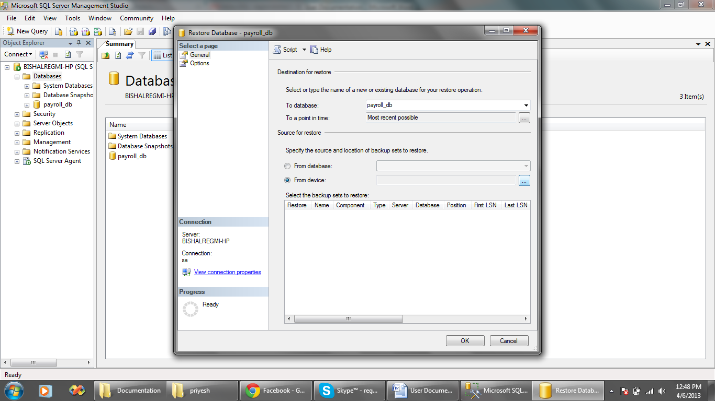

1. A dialog box appears. Click Add and then specify location for the backup file. Click OK. Click OK again.

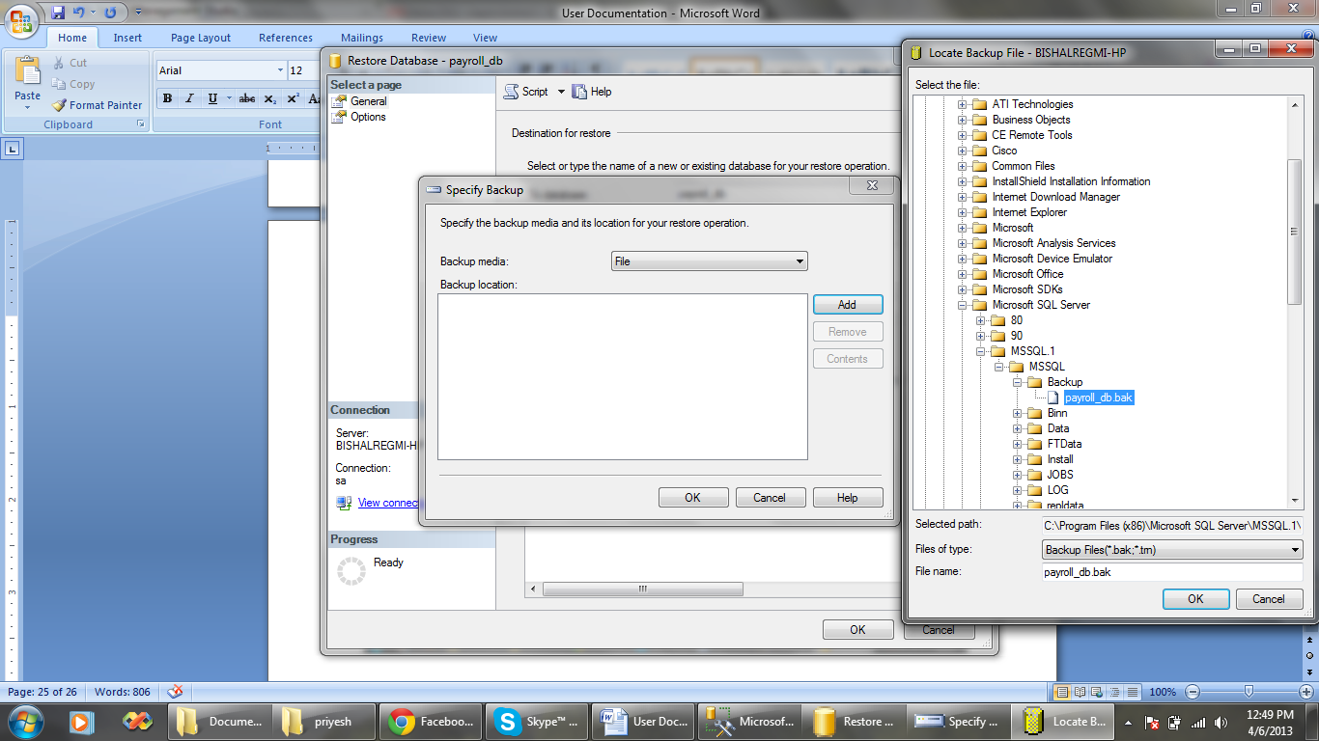

1. Select the components to restore. Click OK.

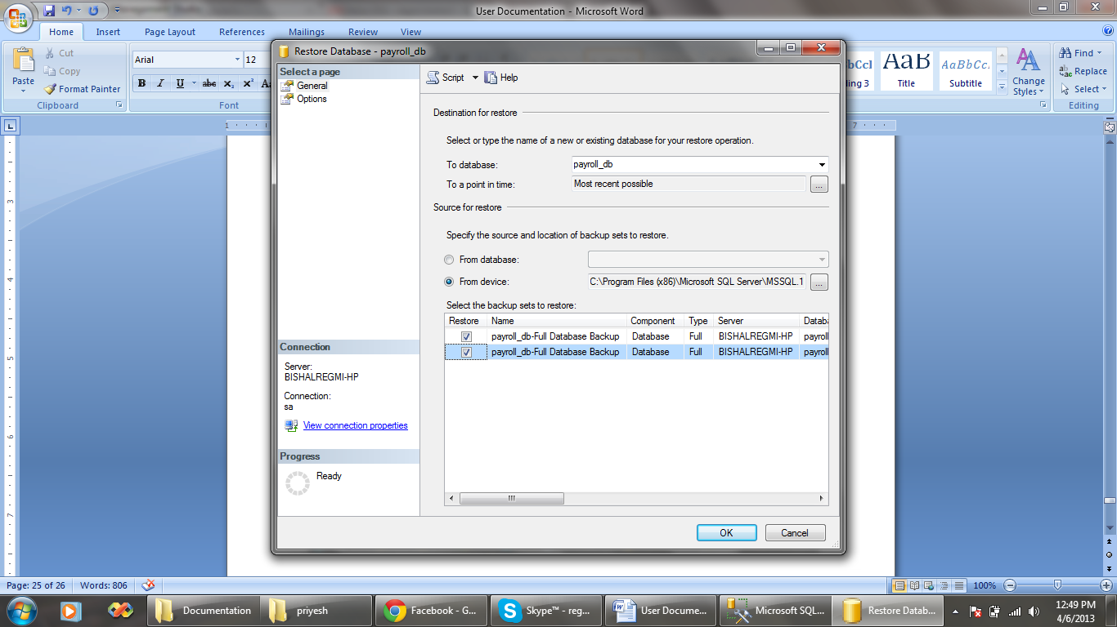

# Troubleshooting/Frequently Asked Questions (FAQs)

*Q:* I don’t see the application icon. How do I open the application?

*A:* Click on Start. Go to All Programs. Click the application name Payroll.

*Q:* How do I log out the application?

*A:* There is no special option to log out. You need to exit the system and re-open the application for logging out.

*Q:* Can I change the daily attendance for an employee whose attendance is already marked?

*A:* No, such changes cannot be made. Once the attendance for a particular day is marked it cannot be changed.